ALMONTE SANITARY DISTRICT
P.O. BOX 698, MILL VALLEY, CALIFORNIA 94942-0689 (415) 388-8775

DIRECTORS DISTRICT MANAGER
Lew Kious, Chair Shonn Dougherty
Anne Lahaderne, Secretary-Treasurer
Linda Rames
Robert Cox

Minutes from December 14, 2020
Regular Meeting of the Board of Directors
at Sewerage Agency of Southern Marin
450 Sycamore Avenue, Mill Valley

- Call to Order: Chair Kious called the meeting to order at 5:02 P.M. Present: (Via Zoom Video Platform) Lew Kious, Anne Lahaderne, Linda Rames, Robert Cox, Dave Haflich, Shonn Dougherty (District Manager).

- Approval of Minutes for November 16, 2020 Meeting. Motion to Approve by Linda, Seconded by Robert. Approved 4-0.
- Public Open Time: No Public.

- Secretary-Treasurer’s Report: Anne reported as of this warrant cycle in fiscal 2020-2021, we have spent, $327,217.99 which is 29.3% of the annual budget. This period equates to 50% of the 2020-2021 annual budget. We have $657,703.63 remaining in reserves. Motion to approve Warrant List and payroll made by Robert, Seconded by Lew. Approved 4-0.

- Reports by Representatives to Other Meetings: Lew reported on November’s SASM meeting since Almonte’s November meeting was held before SASM’s. The main item discussed was an emergency repair on the roof of SASM’s main digester. The Board authorized $1.8 million dollars for an emergency repair on the number one digester.

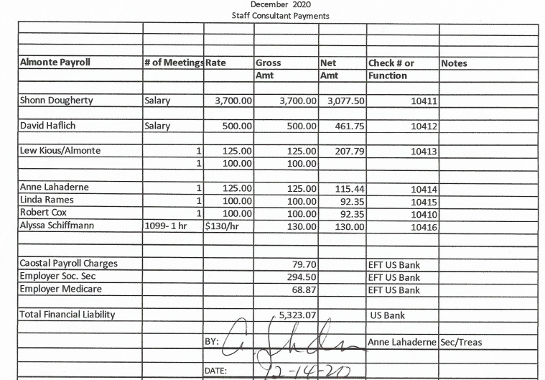
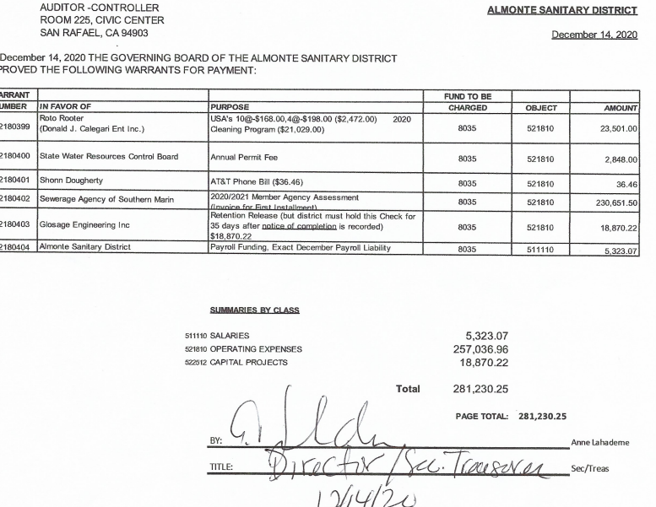

6. Manager’s Report: A comprehensive Manager’s report was included in the Board Packet.

7. New Business:
4 Parcels Back Charges- Special District Assessment (Ordinance 2015-02)
Brandon Halter advised that the Marin County Department of Finance is responsible for collecting any back charges from homeowners. Brandon is still working on how to proceed with the legality of the situation.

8. Old Business: New Auditor FY 2019-2020
Shonn presented the Board with four CPAs to complete the 2019-2020 audit. The Board reviewed 4 RFP’s by local firms. Motion to approve R J Ricciardi as the awarded firm made by Linda, seconded by Anne. Approved 4-0. Robert added a stipulation to the approved vote. R J Ricciardi must put in writing they will start the audit by April 2021 and give Almonte a firm completion date.

9. Board Directors Members Open Time:

10. Next Meeting Date: January 25, 2021 @ 5pm.

11. Adjournment: The meeting was adjourned at 5:32pm. Motion to adjourn made by
Anne, Seconded by Linda. Approved 4-0.

2020 Almonte Sanitary District Election Resolution- Board voted to approve Resolution 2019-1 for 3, four-year terms with candidate’s publication paid by the 4

